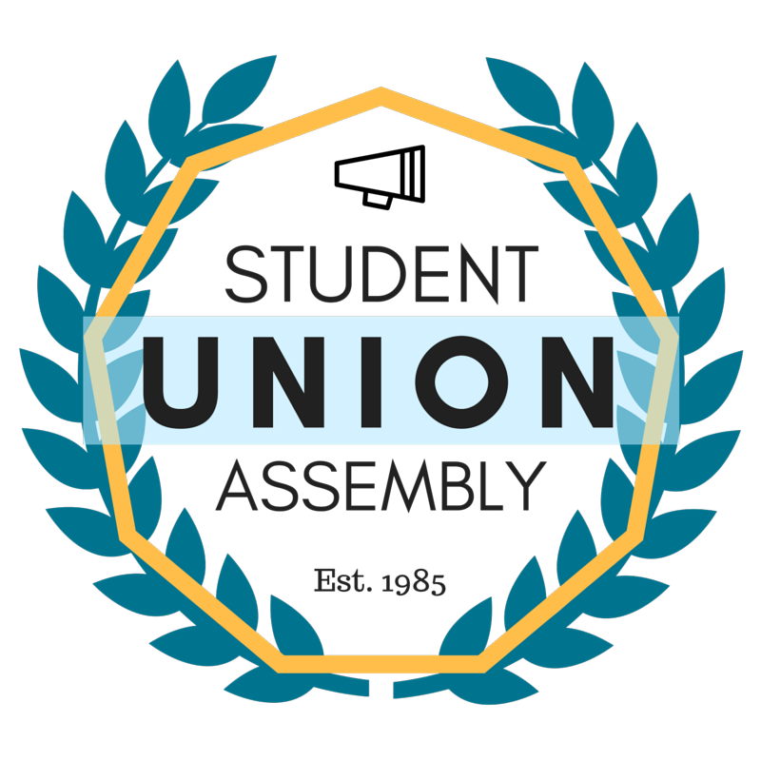
Student Union Assembly
Monthly Report
________________________________________________________________________________
SUA Mailstop: SOAR, 1156 High Street, Santa Cruz CA 95064 • P: 831.459.4838
suapres@ucsc.edu • sua.ucsc.edu
Under My duties as Vice President of Diversity and Inclusion of the Student Union Assembly and Article III Section A Subsection 6(l) of the SUA Constitution, I present my August 2016 monthly report and evaluation to the Assembly. I will outline all of my events, logistical planning, activities and constructive criticism with areas of improvement in hopes of providing a detailed account in the month’s report.

Ongoing and Completed Tasks
Online Diversity Training
Have begun to help in the creation of an online Diversity Training Program
Sarah Latham
Met with Sarah Latham for SUA meet and Greet
SOFA
Partially organized and attended quarterly SOFA meeting
CAAD
Continue to attend bi-monthly meetings, discuss TOE, and potential event at UCSC sponsored by committee.
SCA
Continue to attend weekly meetings, recap on town hall and organize information received.
MSA
Continue to meet weekly with MSA leadership and attended MSA event.
MCC Committee
Have joined the MCC Planning committee, focusing on event advertisement details.
SUA and UCSCPD
Held BBQ and Badges event with UCSC PD Department
UCSA
Attended UCSA-UC sanctuary school call.
SOCC
Attended and took UCSC students to SOCC conference at UC Irvine.
UCSC Admin and SUA
Met with UCSC Administration about ongoing projects.
Feedback
UCSC should have more say on SOCC Planning. SUA meeting times seems to be working better. Officer communication is sometimes lacking. Some SUA leaderhsip needs to get along better.

